IEI JSC CMS TEST REPORT

- Index/Home Page
  - The Institution of Engineers – At Header on Top – The Font Should be – Old English (Font File Attached in Email, download it and install to use).
  - In admin dashboard – carousel image upload – date and time not required delete it.
  - Our Services – Submit your paper in IEI Springer – Write: Submit Papers in Springer Journal of IEI – link will be - https://www.ieindia.org/web/publication#journal.
  - Chairman, IEI Jharkhand – Read Full Profile button – It should be a small button at right corner i.e. right justified. Also keep the profile text Justified.
  - Honorary Secretary, IEI Jharkhand – Read Full Profile button – It should be a small button at right corner i.e. right justified. Also keep the profile text Justified.
  - In footer – Three line definition of IEI is not looking good – remove it – Keep only – Follow us on – Facebook, Twitter and LinkedIn – Logo with links.
  - In footer – Under Contact – The second line should start just from the below of Engineer Bhawan – Align/Give Space – Also Bhawan spelling wrong – Write Bhawan.
  - In footer – Under Contact – Give space and dash after STD code – Number should look like: +91 – 651 – 3510412.
  - In admin dashboard – announcement – only date and time is required – time not showing on homepage – Also delete Content, it is not required.
  - In footer – Under Documents – The links used for IEI Headquarter is wrong – Insert – www.ieindia.org.

- About Us
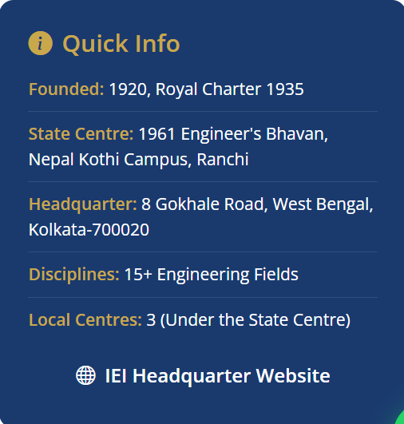

This should be Look Like as shown below :-



Established: In 1920, Royal Charter in
1935
Ranchi Centre: Upgraded to
Jharkhand State Centre
in 2001

Headquarter: 8 Gokhale Road, Kolkata –
700020, West Bengal
Disciplines: 15+ Engineering Branches
Jharkhand Local Centre: Bokaro Steel
City, Dhanbad
and
Jamshedpur

(Try to write after colon (:) and justified)

IEI headquarter Website Link is wrong. Use www.ieindia.org

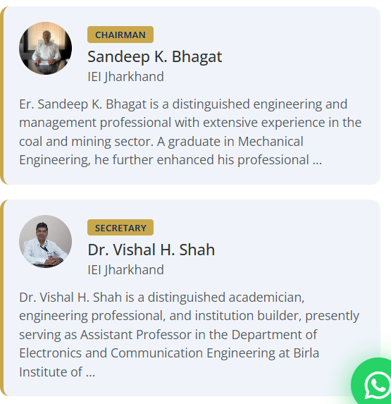

Use read more button here also and keep the text justified. Incomplete profile here is not looking nice.

- Members
  - In admin dashboard under Members – Add Member – Mobile Number and Membership Number not required – Delete it.
  - Sub Committee members name is not being displayed category wise.
  - Senior Member not being displayed is not being displayed after saving it from dashboard.

- Membership
There will be Changes in membership dropdown menu, Follow this :-

  - Corporate Membership – Incorrect link – Use – https://ipanel.ieindia.org/WebUI/IEI-RegistrationForMembApp.aspx
  - Student Member – Use Link – https://ipanel.ieindia.org/WebUI/IEI-RegistrationForMembApp.aspx
  - Member Technologist – Use Link - https://www.ieindia.org/web/becomemember#
  - Associate Member Technologist – Use Link – https://www.ieindia.org/web/becomemember#
  - Institutional Membership – Use Link – https://www.ieindia.org/web/imember#
  - Remove – Know Your Member – From the list

- Event Gallery
  - Images not being displayed is not being displayed after saving it from dashboard.
  - Created at time is not required while creating events from the admin dashboard.

- Downloads
  - Created at time is not required while creating events from the admin dashboard.

- Careers
  - In admin dashboard careers menu is written as vacancies, please change it to Careers.
  - Created at time is not required while creating events from the admin dashboard.
  - There is no apply button for published vacancies. Either create a apply button and then create a form for the same of simply with resume upload option and show it in admin dashboard.

- Guest House
  - Show room name at top and then the room number below
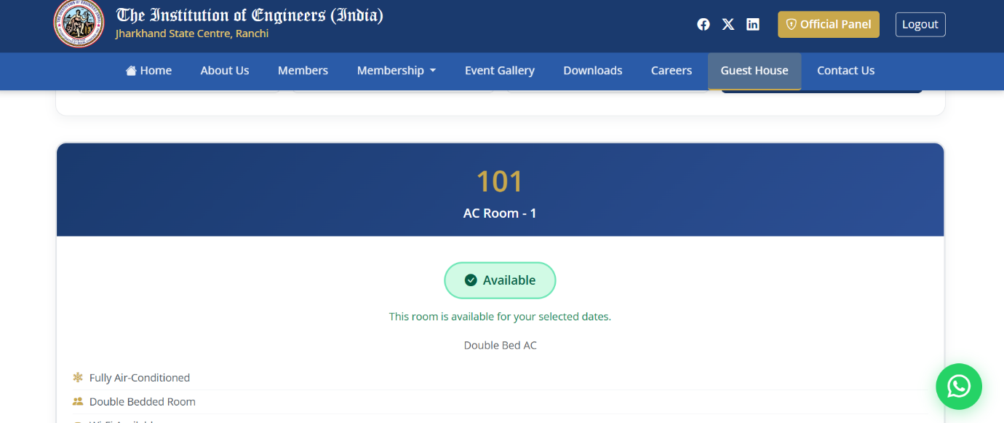
  - Show room name at top and then the room number below
  - Number of person while booking is taking any value. Validation should be there for single room and double room.
  - Booking room check is taking back dates also, validate it.
  - Time not required while Guest Booking menu.

- Contact Us
  - Google map not working.

- Admin Dashboard
  - In admin dashboard login. I need to understand what is Groups and Users under the menu Authentication and Authorization, before I can test.

- Suggestion
  - If you can delete the office login button from the home page. It looks nice. The admin portal will be accessible via a link e.g. www.iei.com/admin

